MEWA COMMUNITY FORUM

**MUHAMMAD IBRAR KHAN HABIBULLAH KHAN**



DEPARTMENT OF COMPUTER SCIENCES

COMSATS UNIVERSITY ISLAMABAD, WAH CAMPUS

WAH CANTT – PAKISTAN

SESSION 2018-2021

MEWA COMMUNITY FORUM

*Undertaken By:*

**MUHAMMAD IBRAR KHAN**

REG. NO. CIIT/SP18-BCS-058/WAH

**HABIBULLAH KHAN**

REG. NO. CIIT/SP18-BCS-088/WAH

*Supervised By:*

**DR SULMA RASHID**



A DISSERTATION SUBMITTED AS A PARTIAL FULFILLMENT OF THE REQUIREMENTS FOR THE DEGREE OF BACHELORS IN COMPUTER SCIENCE / SOFTWARE ENGINEERING

DEPARTMENT OF COMPUTER SCIENCES

COMSATS UNIVESITY ISLAMABAD, WAH CAMPUS

WAH CANTT – PAKISTAN

SESSION 2018-2021

**FINAL APPROVAL**

The final approval page will be provided by the department after the final evaluation.

**DEDICATION**

We dedicated all our efforts and struggles to our beloved parents for their support and encouragements throughout my life. I would like to devote this research to our respected faculty teachers who developed skills in us which enable us to do this research and taught us to the path of justice and honesty that would help us as a professional.

**ACKNOWLEDGEMENT**

I would like to express our gratitude to Allah Almighty to enabling us to complete this report**.**

Successfully completion of any type of project requires help of number of persons so firstly we convey our sincere gratitude to our supervisor **DR SULMA RASHID.** Without his kind direction and proper guidance this project would have been a little success. In every phase of this project his supervision and guidance shaped the project and report to be completed perfectly.

**PROJECT BRIEF**

PROJECT NAME MEWA COMMUNITY FORUM ORGANIZATION NAME COMSATS UNIVERSITY ISLAMABAD,

WAH CAMPUS

OBJECTIVE TO DESIGN ONLINE SYSTEM FOR MEWA COMMUNITY FORUM

UNDERTAKEN BY MUHAMMAD IBRAR KHAN

HABIBULLAH KHAN

SUPERVISED BY DR SULMA RASHID LECTURER

DEPARTMENT OF COMPUTER SCIENCE COMSATS UNIVERSITY ISLAMABAD, WAH CAMPUS

STARTED ON MARCH 2020

COMPLETED ON DECEMBER 2020

COMPUTER USED CORE I-5 10TH GEN SOURCE LANGUAGE LARAVEL

OPERATING SYSTEM WINDOWS 10, ANDROID

TOOLS USED VISUAL STUDIO CODE & MYSQL

**ABSTRACT**

The capstone project we have been working on is about the development of a web for a MEWA COMMUNITY FORUM. This application also called MEWA COMMUNITY FORUM has a purpose to help user to ask her queries to committee members. As we all know in our country people are in various problems and have no one to talk about. Nobody wants to listen to their problems and hence they are left unchecked. So, we decided to make a welfare association starting from Mianwali to address different issues of the folks. There were different associations which were working for mostly health but in our society, we will be covering almost all the issues. By proposing the system, we will benefit the members of the association and the people who want help in their time of need by contacting their desired person who will be solving their problem. Which would save their time and energy. Also, we will be beneficial for those members which find it difficult to talk face to face.

**TABLE OF CONTENS**

1. INTRODUCTION 1
   1. System Introduction 1
   2. Background of the System 1
   3. Objectives of the System 1
   4. Significance of the System 2
2. REQUIREMENT SPECIFICATIONS 2
   1. Product Scope 3
   2. Product Description 3
      1. Product Perspective 3
      2. Product Functionality 3
      3. Users and Characteristics 3
      4. Operating Environment 4
   3. Specific Requirements 4
      1. Behavioral Requirements 7
      2. External Interface Requirements 12
   4. Non-functional Requirements 15
      1. Performance Requirements 15
      2. Safety and Security Requirements 15
      3. Software Quality Attributes 16
3. DESIGN SPECIFICATIONS 17
   1. Introduction 17
   2. Composite Viewpoint 17
   3. Logical Viewpoint 17
   4. Information Viewpoint 18
   5. Interaction Viewpoint 19
   6. State Dynamics Viewpoint 21
   7. Algorithmic Viewpoint 22
4. DEVELOPMENT AND TOOLS 24
   1. Introduction 24
   2. Development Plan 24
   3. Development Tools 25
   4. Conclusion and Future Work/Extensions 25
5. QUALITY ASSURANCE 26
   1. Introduction 26
   2. Traceability Matrix 26
   3. Test Plan 27
6. USER MANUAL 30
   1. Introduction 30
   2. Hardware/Software Requirements for the System 30
   3. Installation guide for Application 30
   4. Operating Manual 43
      1. Website Operating Manual 43

**LIST OF FIGURES**

Figure 1 : Use Case Diagram 7

Figure 2 : Home 13

Figure 3 : Events 14

Figure 4 : Contacts 14

Figure 5 : Logical Viewpoint 17

Figure 6 : Class Diagram 17

Figure 7 : ERD Diagram 18

Figure 8 : USER 19

Figure 9 : USER 20

Figure 10 : USER 20

Figure 11 : State Machine Diagram 21

Figure 12 : Pseudo Code Diagram 23

Figure 13 : Gant Chart 24

Figure 14 : Traceability Matrix 27

Figure 15 : Laravel Composer 31

Figure 16 : Download Composer 32

Figure 17 : Install Composer 33

Figure 18 : CMD Composer 34

Figure 19 : Configure Composer 35

Figure 20 : Composer Key Set Successfully 35

Figure 21 : php artisan serve 36

Figure 22 : local host 37

Figure 23 : Visual Studio Code 37

Figure 24 : Setup Agreement 38

Figure 25 : Installation Path 39

Figure 26 : Additional Task 40

Figure 27 : Install VS Code 41

Figure 28 : Finish VS Code 42

Figure 29 : VS Code Editor 43

Figure 30 : Home Page 44

Figure 31 : Contacts 45

Figure 32 : Registration 45

Figure 33 : Login 46

Figure 34 : MEWA Admin 46

Figure 35 : MEWA User 47

Figure 36 : MEWA Professionals 47

**LIST OF TABLES**

Table 5. 1: Test Case for User Signup 27

Table 5. 2: Test case for User Fail Signup 28

Table 5. 3: Test case for User Login 28

Table 5. 4: Test case for Wrong Username 28

Table 5. 5: Test case for Wrong Password 29

Table 5. 6: Add User 29

Table 5. 7: Post a Question 29

# INTRODUCTION

This chapter provides the overview of the project. The brief introduction, purpose of the document, scope, overview and the significance of this project.

## System Introduction

MEWA (Mianwalians Executives Welfare Association) is an automated management system in which we want to address the issues of the people who are somehow in need for something. As we all know in our country people are in various problems and have no one to talk about. Nobody wants to listen to their problems and hence they are left unchecked. So, we decided to make a welfare association starting from Mianwali to address different issues of the folks. There were different associations which were working for mostly health but in our society, we will be covering almost all the issues.

By proposing the system, we will benefit the members of the association and the people who want help in their time of need by contacting their desired person who will be solving their problem. Which would save their time and energy. Also, I will be beneficial for those members which find it difficult to talk face to face

## Background of the System

As discussed above there was no other automated system of this idea in our vision. This type of automated system is a unique idea because these types of societies were not given any attention. But our society acted about this matter. It was discussed in every meeting to address the problems of members more precisely.

You can say there were some manual systems which used different techniques to address issues. We will take from them, but the automated system will be the first experience in our region. We will try to work hard in the requirement phase to ensure minimum bugs in our system. The already used manual technique will also be followed in some extent. Like if any person faces any type of difficulty, he/she can ask the professionals for help within the community. They must be the part of the community to make a complaint against anyone.

Anyone who is either related to health, or a social activist or related to law-and-order organizations can be a member of the society by registering and he can help anyone in their type of need voluntarily.

## Objectives of the System

* + - Complaint Registration
    - Resolve Health Issues
    - Resolve Education Issues
    - Resolve Legal Issues
    - Ease for every Member

## Significance of the System

The significance of MEWA is defined in such a way that this management system or welfare association plays a very important role for the members which are not other than needy people. In most of the times we notice that general public or middle-class people are neglected by thehigher ups and those who are in power or there are other factors like, some people facefinancial issues due to which they cannot afford their daily living and hence they are really deprived of the basic necessities of life. In other cases, we notice that some people face health issues more importantly when a person below the belt faces this problem, he is all alone, and no one is willing to do anything for him. Because they are not that much rich, they cannot take good care of themselves and can face some issues. The other and the most important reason is harassment or bullying. Some males and females face harassment and bullying. They are afraid to speak in front of everyone and hence they are mentally tortured.

In this regard there was urgent need of a management system in which anyone can register complaint regarding his/her issue. In this way they will not be disclosed by society members and officials and their problems will be solved. Also, due to the diversion in the society members at least there will be a single person to help them in their required issue. By doing this many people will be facilitated.

# REQUIREMENT SPECIFICATIONS

This chapter provides the overview of the project requirements. The brief introduction of operating environment, scope, product description and the types of requirements for this project.

## Product Scope

MEWA is a web-based system which will allow the needy with the professionals of the welfare society. It will help individuals to register an issue that can be either financial, health related or some harassment. The user can also get registered in this portal to be able to use more features and be a part of the welfare society.

This application will deal with all types of reports, and they will be verified by contacting the registrars by which we can get to know about some pranksters and the people who are actually in genuine need. You can also post a question on the website which will be answered by the professionals of the society if they are valid questions.

## Product Description

### Product Perspective

MEWA is a peer-to-peer complaint registration or interaction portal. It uses its free and open standards to make registering complaints online more interactive. It will be developed as an open-source application without need of an external downloads and plugins. There is not a welfare society’s automated management system in the market either it is mobile app or a web- based application. Our system will be first management system in our region which will be able to address almost every type of problem’s solutions. You can say that our system will be the replacement of the manual system which is already being used by almost all the societies.

### Product Functionality

* + - * Sign Up
      * Login
      * Add User
      * Delete User
      * Post a Question.
      * Newsletter Subscription

### Users and Characteristics

1. Admin/Professional Member
2. User
   1. **Admin/Professional Member:**

Admin/Professional Member is the user with the highest authority in this system. We can say that he will be managing the overall system. The duties of admin are adding user, delete user, update user, check complaint, contact the person who filed a complaint, see questions and give the answers. He will be all in all of the system.

* 1. **User:**

The other user of the system is an ordinary user who can be a member of the society or some random person who needs some assistance. The user can post a question on the portal which will be answered by the admin. He/she can get registered to the portal and make complaint on the portal or can get help in some personal matters which they are not able to solve.

### Operating Environment

**OE-1:** The System shall operate correctly with the following web browsers: Firefox versions 43 through 46; Google Chrome (all versions); and Opera versions 18, 34 through 37.4

**OE-2:** The system would run on all major operating systems as long as a browser is supported by the said OS. Some of the operating systems that will be able to run our system include: Microsoft Windows 10 and Linux. The system may not work on early versions of windows.

**OE-3:** The System shall be able to display GPS location for environment like windows and Linux.

## Specific Requirements

**Description of FR-01**

|  |  |
| --- | --- |
| **Identifier** | FR-01 |
| **Title** | Confirm account signup |
| **Requirement** | Signing up or registering makes a person enabled to use the more functionalities, this asks for the email ID or phone and a password for accessing your account later. |
| **Source** | Signup form submission |
| **Rationale** | To authenticate user and allow data access. |
| **Business Rule (if**  **required)** | N/A |
| **Dependencies** | N/A |
| **Priority** | High |

**Description of FR-02**

|  |  |
| --- | --- |
| **Identifier** | FR-02 |
| **Title** | Verify login details |
| **Requirement** | The system shall match all the credentials provided by the user in the database. |
| **Source** | Login form submission. |
| **Rationale** | To check if an account exists for the provided credentials or not. |
| **Business Rule (if**  **required)** | N/A |
| **Dependencies** | FR-01 |
| **Priority** | High |

**Description of FR-03**

|  |  |
| --- | --- |
| **Identifier** | FR-03 |
| **Title** | Add user |
| **Requirement** | Admin shall be able to add the detail of a new User to the system. |
| **Source** | Supervisor. |
| **Rationale** | Admin will be able to add a new user. |
| **Business Rule (if**  **required)** | N/A |
| **Dependencies** | N/A |

|  |  |
| --- | --- |
| **Priority** | High |

**Description of FR-04**

|  |  |
| --- | --- |
| **Identifier** | FR-04 |
| **Title** | Delete user |
| **Requirement** | Admin shall be able to Delete the record of the user from the data base. |
| **Source** | Supervisor. |
| **Rationale** | Admin will be able to Delete the registered user from the data base. |
| **Business Rule (if**  **required)** | N/A |
| **Dependencies** | N/A |
| **Priority** | High |

**Description of FR-05**

|  |  |
| --- | --- |
| **Identifier** | FR-05 |
| **Title** | Post a Question |
| **Requirement** | The system shall allow the users of the system to post a question. |
| **Source** | Supervisor. |
| **Rationale** | N/A |
| **Business Rule (if**  **required)** | N/A |
| **Dependencies** | N/A |
| **Priority** | High. |

**Description of FR-06**

|  |  |
| --- | --- |
| **Identifier** | FR-06 |
| **Title** | Newsletter Subscription |
| **Requirement** | The system shall allow the users of the system to subscribe to the newsletter. |
| **Source** | Supervisor. |
| **Rationale** | N/A |
| **Business Rule (if required)** | N/A |
| **Dependencies** | N/A |
| **Priority** | High. |

### Behavioral Requirements

**USE CASE DIAGRAM:**

Figure depicts an administrator's use scenario in which he or she has access to the problem. The use case shown in the diagram is for users who have access to an online website for raising their problem.

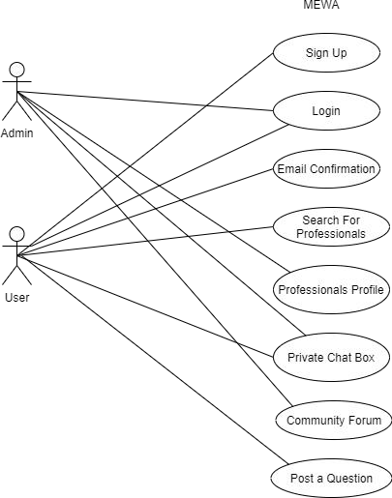

**Figure** **1: Use Case Diagram**

* **Signup:**

User can sign up by filling the signup form by providing required information.

|  |  |
| --- | --- |
| **Use Case ID:** | UC-1 |
| **Use Case Name:** | Signup |
| **Actors:** | User: Admin |
| **Description:** | User signs up by filling the signup by providing the required information that  will redirect the user to the login page. |
| **Trigger:** | User clicks on the signup button. |
| **Preconditions:** | None |
| **Post conditions:** | POST-1. User’s account will be created and will become a registered member of the system.  POST-2. Account confirmation email is sent to the user. |
| **Normal Flow:** | 1. User will launch the application. 2. The system will display a login page to the user. The system will prompt the user to enter their credentials to login the system and a signup button for unregistered users. 3. The user will click on the signup button. 4. The system will display a signup form to the user. 5. The user will enter valid CNIC, email, name, age, phone no, password, etc. 6. The system receives these details and further validates whether they are correct or not. 7. After validation, the system will create the account of the user and will redirect the user to the login page. |
| **Alternative Flows: [Alternative Flow 1 – Not in Network]** | N.A |
| **Exceptions:** | 5a. In step 5 if the information provided by the user already exist in the system.   1. The system will display an error that the sing up is unsuccessful. 2. The system will prompt the user to enter unique username, CNIC, email address. 3. Use case resumes on step 5. |
| **Business Rules** | N.A |
| **Assumptions:** | User enters unique username and CNIC. |

* **Login:**

User login to the system by providing required information.

|  |  |
| --- | --- |
| **Use Case ID:** | UC-2 |
| **Use Case Name:** | Login |
| **Actors:** | User: Admin |
| **Description:** | User login to the system by providing the required credentials. Credentials  include CNIC and a password that will redirect the user to the home page. |
| **Trigger:** | User clicks on the login button. |

|  |  |
| --- | --- |
| **Preconditions:** | PRE-1. User must be a registered member of the system. |
| **Post conditions:** | POST-1. System will redirect the user to the home page. |
| **Normal Flow:** | 1. User will launch the application. 2. The system will display a login page to the user. The system will prompt the user to enter their credentials to login the system and a signup button for unregistered users. 3. The user enters their login details and clicks the login button. 4. The system receives these details and further validates whether they are correct or not. 5. After validation, the system will redirect the user to the home page where he/she can access all features of the application. |
| **Alternative Flows: [Alternative Flow 1 – Not in Network]** | N.A |
| **Exceptions:** | 3a. In step 3 if the user enters the credentials without having an account or if the registered user enters the incorrect credentials.   1. The system will display an error that the given user must register himself first. 2. The system will prompt the registered user to enter correct CNIC or password. 3. Use case resumes on step 2. |
| **Business Rules** | N.A |
| **Assumptions:** | User remembers his credentials. |

* **Email Confirmation:**

User email will be confirmed.

|  |  |
| --- | --- |
| **Use Case ID:** | UC-3 |
| **Use Case Name:** | Email Confirmation |
| **Actors:** | User |
| **Description:** | User’s email will be confirmed |
| **Trigger:** | User Selects signup option |
| **Preconditions:** | PRE-1. User must provide all credentials and sign up. |
| **Post conditions:** | POST-1. User’s account is updated successfully. |
| **Normal Flow:** | 1. User will select the sign-up option. 2. The system will redirect the user to email confirmation. 3. The user will confirm email. 4. The system will display a confirmation message to the user. |
| **Alternative Flows:** | N.A |
| **[Alternative**  **Flow 1 – Not in Network]** |  |
| **Exceptions:** | N.A |
| **Business Rules** | N.A |
| **Assumptions:** | N.A |

* **Search For Professional:**

User can search for the professional according to their need.

|  |  |
| --- | --- |
| **Use Case ID:** | UC-4 |
| **Use Case Name:** | Search For Professionals |
| **Actors:** | User |
| **Description:** | User can search for professionals |
| **Trigger:** | User selects the search for professionals |
| **Preconditions:** | PRE-1. User must open the portal. |
| **Post conditions:** | POST-1. User found the professional |
| **Normal Flow:** | 1. User will select the search for professional option. 2. Search will start. 3. User will select the desired professional. |
| **Alternative Flows: [Alternative Flow 1 – Not in Network]** | N.A |
| **Exceptions:** | N.A |
| **Business Rules** | N.A |
| **Assumptions:** | N.A |

* **Professional Profile:**

Admin can add, delete, update and view professional’s profile according to the need of the association.

|  |  |
| --- | --- |
| **Use Case ID:** | UC-5 |

|  |  |
| --- | --- |
| **Use Case Name:** | Professional’s Profile |
| **Actors:** | Admin |
| **Description:** | Admin can add, delete, update and view professional’s profile. |
| **Trigger:** | Admin selects professional’s profile |
| **Preconditions:** | PRE-1. Admin must be a registered person. |
| **Post conditions:** | POST-1. Changes are applied. |
| **Normal Flow:** | 1. Admin will select professional’s profile. 2. Make the required changes. 3. Save the changes. |
| **Alternative Flows: [Alternative Flow 1 – Not in**  **Network]** | N.A |
| **Exceptions:** | N.A |
| **Business Rules** | N.A |
| **Assumptions:** | N.A |

* **Private Chat Box:**

User can post questions in chat box according to their required help and admin can handle those questions.

|  |  |
| --- | --- |
| **Use Case ID:** | UC-6 |
| **Use Case Name:** | Private Chat Box |
| **Actors:** | User: Admin |
| **Description:** | User can post questions in chat box and admin can answer those questions. |
| **Trigger:** | User selects the private chat box option. |
| **Preconditions:** | PRE-1. User must be a registered member of the system. PRE-2. User is already logged in to the system. |
| **Post conditions:** | POST-1. User’s questions have been answered. |
| **Normal Flow:** | 1. User will select private chat box option. 2. Admin receives a request. 3. User will send his problem through that chat box. 4. Admin will assign him a professional or help him with the question. 5. Chat ends. |
| **Alternative Flows: [Alternative Flow 1 – Not in Network]** | N.A |
| **Exceptions:** | N.A |
| **Business Rules** | N.A |
| **Assumptions:** | N.A |

* **Community Forum:**

Admins will gather for problems

|  |  |
| --- | --- |
| **Use Case ID:** | UC-7 |
| **Use Case Name:** | Community Forum |
| **Actors:** | Admin |
| **Description:** | Admins will gather for problems. |
| **Trigger:** | N.A |
| **Preconditions:** | N.A |
| **Post conditions:** | N.A |
| **Normal Flow:** | N.A |
| **Alternative Flows: [Alternative Flow 1 – Not in Network]** | N.A |
| **Exceptions:** | N.A |
| **Business Rules** | N.A |
| **Assumptions:** | N.A |

* **Post a Question:**

User can post a question.

|  |  |
| --- | --- |
| **Use Case ID:** | UC-8 |
| **Use Case Name:** | Post a Question |
| **Actors:** | User |
| **Description:** | User can post a question |
| **Trigger:** | User selects the post a question option |
| **Preconditions:** | PRE-1. User must be a registered member of the system. PRE-2. User is already logged in to the system. |
| **Post conditions:** | POST-1. User’s question is answered. |
| **Normal Flow:** | 1. User will select post a question option. 2. Admin will check the question. 3. Question will be answered. |
| **Alternative Flows: [Alternative Flow 1 – Not in**  **Network]** | N.A |
| **Exceptions:** | N.A |
| **Business Rules** | N.A |
| **Assumptions:** | N.A |

### External Interface Requirements

* + - 1. **User Interface**

The front-end of this application will be developed using HTML, CSS, Bootstrap. The guidelines mentioned in their official documentation will be followed.

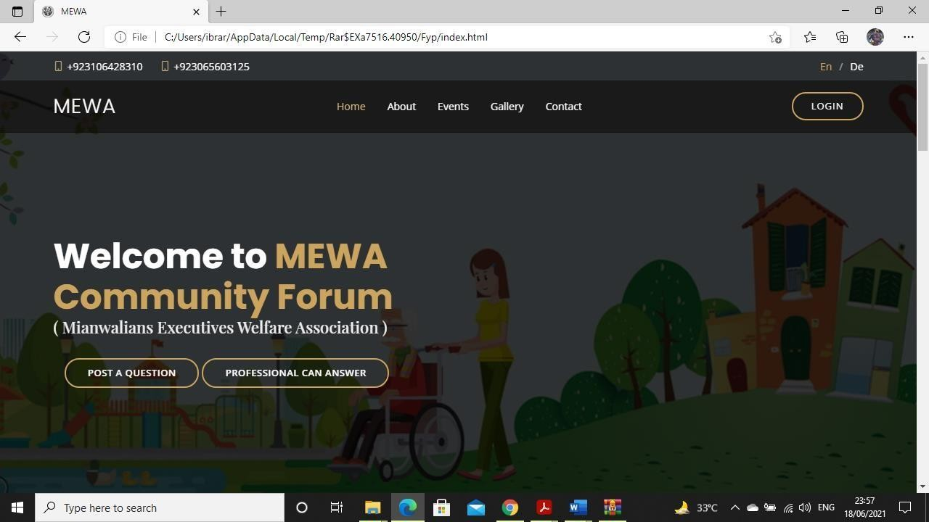

**Figure** **2: Home**

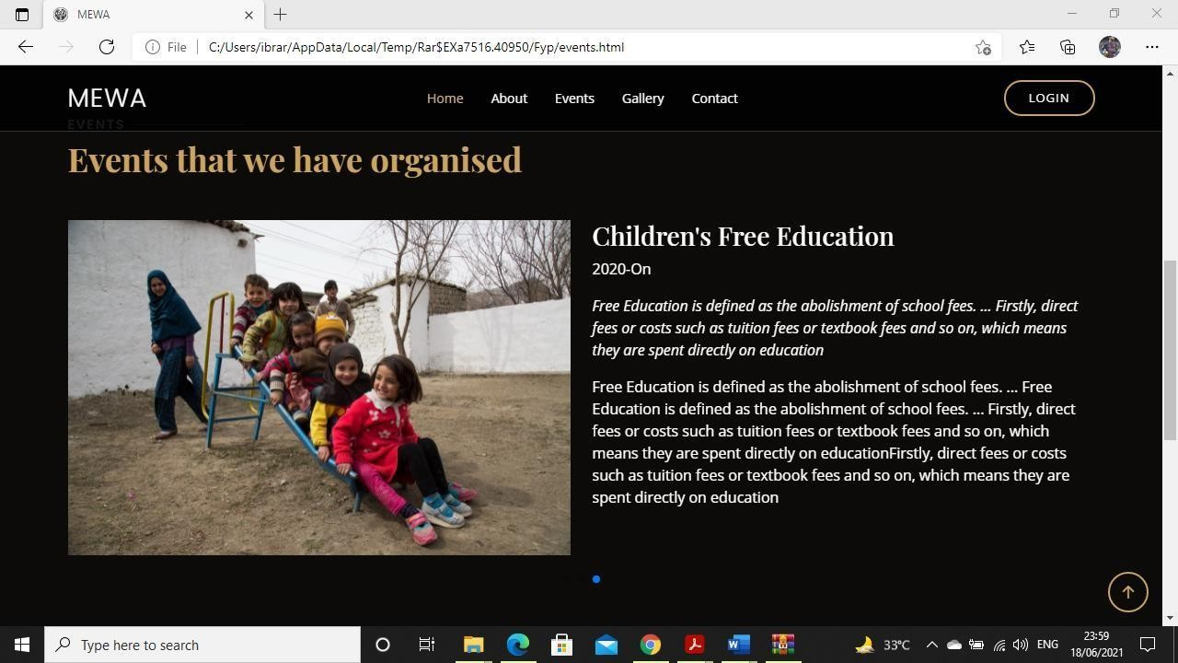

**Figure 3****: Events**

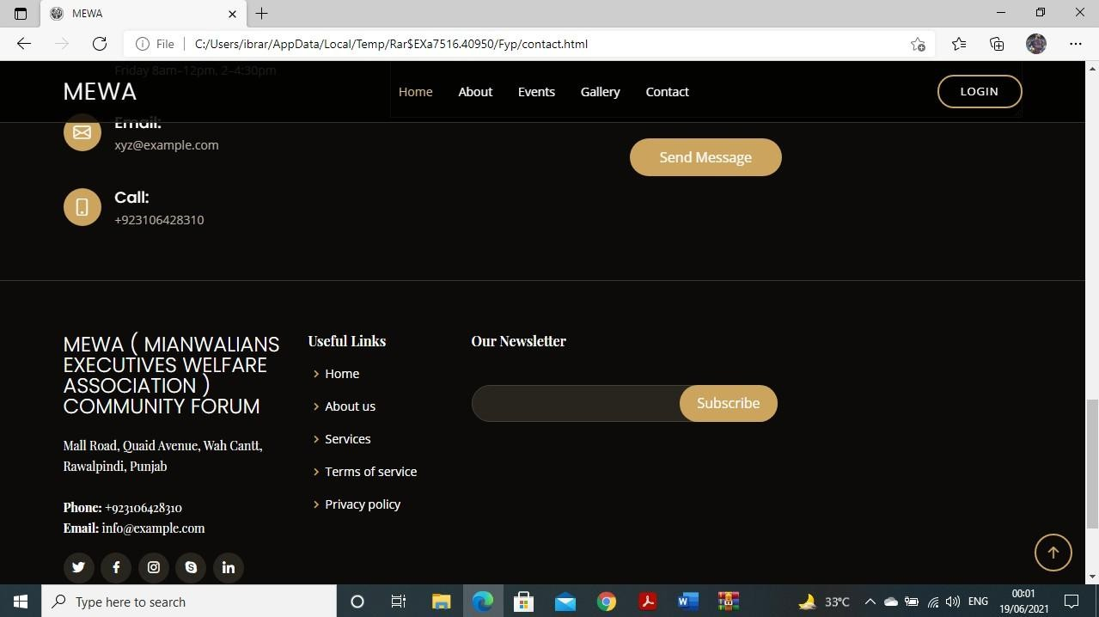

**Figure 4****: Contacts**

* + - 1. **Other Interfaces (if any)**
         1. **Hardware Interfaces**

MS Windows, Linux, Unix, Ubuntu

Any Computer which supports browsers and support HTML, CSS, Bootstrap.

* + - * 1. **Software Interfaces**

The system will be operated on Android, OS and web browser will support the versions.

MySQL Database will be used to store user history and preferences and other important computational data.

PHP and Laravel will be used for back-end queries.

* + - * 1. **Communications Interfaces**

The communication will take place over WIFI so therefore network communication protocols will be in place. The emails will be used to create accounts and to validate the authenticity of the account via a confirmation pin.

## Non-functional Requirements

### Performance Requirements

**PER-1:** The system shall not take more than 4 seconds to process input requests by the user if the internet connection is strong.

**PER-2:** The user who has fast internet connectivity shall be able to access the page in less than 5 seconds.

### Safety and Security Requirements

**SEC-1:** The system should validate the user’s account during registration using email to make sure that no fake profiles are registered on the system.

**SEC-2:** The system shall keep user data safe and private. Users shall not be able to access another user’s data.

* + 1. **Software Quality Attributes Availability:**

The system should be available on the 24/7 and work perfectly.

**Correctness:**

The system should be well integrated well enough to avoid any entanglement between the works of other admins.

# DESIGN SPECIFICATIONS

## Introduction

A plan determination is a definite archive giving a rundown of focuses in regard to an item or interaction. This part will incorporate the progression of the undertaking and the task graphs to help the client in understanding the venture. It will contain **UML** graphs succession outlines and stream diagram charts. Fundamentally, every one of the clients will be known structure this section about the inward construction of the undertaking.

## Composite Viewpoint

NO COMPOSITE VIEW DIAGRAM

**Figure** **5: Logical Viewpoint**

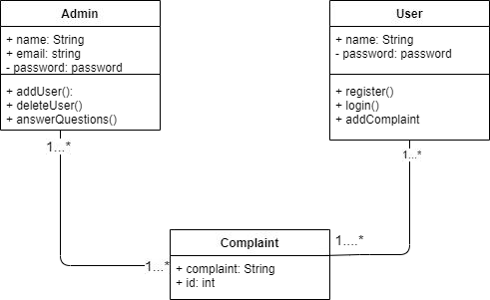

**Figure 6****: Class Diagram**

* 1. **Information Viewpoint**

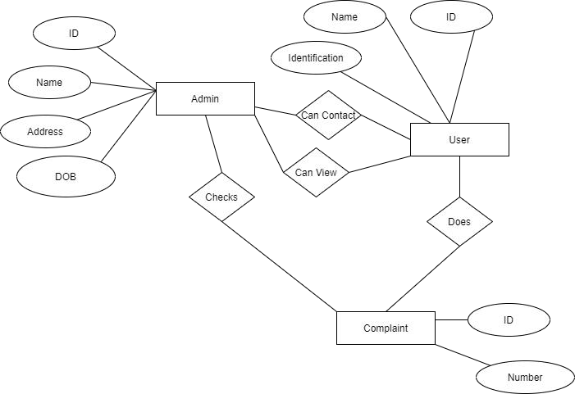

**Figure 7****: ERD Diagram**

* 1. **Interaction Viewpoint**
     1. **USER**

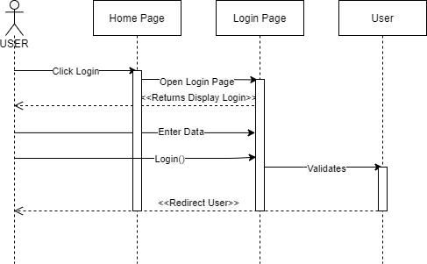

**Figure** **8: USER**

* + 1. **USER**

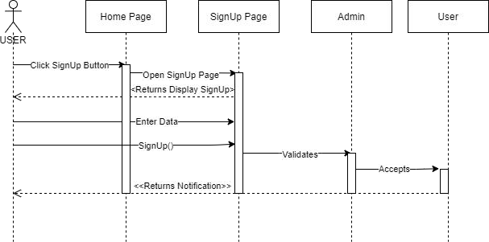

**Figure** **9: USER**

* + 1. **USER**

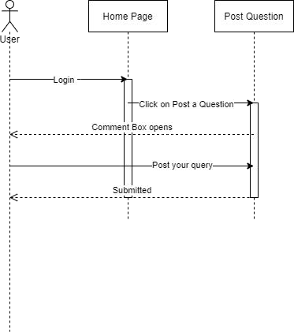

**Figure 1****0: USER**

* 1. **State Dynamics Viewpoint**

**3.5.1** **STATE DIAGRAM**

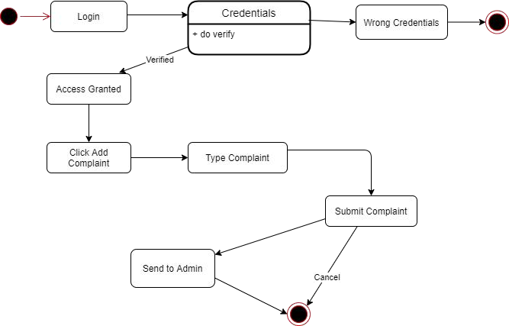

**Figure 11****: State Machine Diagram**

* 1. **Algorithmic Viewpoint**

**Login Page user**

1. Start
2. Open site
3. Enter username and password
4. If username and password match to db username and password
5. Display home page
6. End

**Admin Login Page**

1. Start
2. Open site
3. Enter username and password
4. If username and password match to db username and password
5. Display home page
6. End

**Admin Signup page**

1. Start
2. Open site
3. Click on signup icon
4. Enter credentials in form.
5. Press signup
6. Signup successfully
7. End

**User Signup Page**

1. Start
2. Open site
3. Click on signup icon
4. Enter credentials in form
5. Press signup
6. Signup successfully
7. End

**Make Post**

1. Start
2. Search for professionals
3. Make a post
4. Click submit
5. Professional can answer

7. End

**View Details**

1. Start
2. Click about
3. Check about up
4. Click events
5. See details about events
6. End

**Figure 1****2: Pseudo Code Diagram**

# DEVELOPMENT AND TOOLS

## Introduction

We have basically developed a **Mewa Community Forum** website and for this purpose. We have used **Laravel** which is a framework of **PHP**. Its version is **“8.0”**. We have used MSQL server for the database. We are using windows 10 using Intel processor. We are not using any external communication, all the communication in the software is held within the environment. We are using **HTML and CSS** for frontend and **Laravel** for backend to build the application.

## Development Plan

This project **MEWA COMMUNITY FORUM** is developed by three members. Their names are:

Muhammad Ibrar Khan (SP18 - BCS - 058). Habibullah Khan (SP18 – BCS - 088).

We have majorly divided the project into frontend and backend and then further into task and modules and then implemented it according to modules.

Front end is majorly developed by **Muhammad Ibrar Khan** and backend is majorly developed by **Habibullah Khan** and we all helped each other in their major tasks (i.e., frontend and backend).

**Gant Chat/Table:**

|  |  |  |  |  |  |  |  |
| --- | --- | --- | --- | --- | --- | --- | --- |
| **MEWA COMMUNITY**  **FORUM** | **Jun-24** | **July-12** | **Aug-21** | **Sep-12** | **Oct-20** | **Nov-20** | **Dec-20** |
| Proposal Submission |  |  |  |  |  |  |  |
| Proposal Approval |  |  |  |  |  |  |  |
| SRDS |  |  | |  |  |  |  |
| Prototype |  |  |  | |  |  |  |
| Frontend Development |  |  |  | | |  |  |
| Backend Development |  |  |  | | | |  |
| Testing of System |  |  |  |  |  |  |  |

**Figure 1****3: Gant Chart**

## Development Tools

For this project, the tools we have used are:

* HTML, CSS, Bootstrap.
* Laravel (Ver 8.0)
* MSQL.

## Conclusion and Future Work/Extensions

System is developed for platforms Website. Achieving a well-designed web application for the Capstone project is a process that requires excellent research and thus needs a sense of initiative, responsibility, enthusiasm and involvement. It also requires a clear vision of the desired outcome, and therefore a clear formulation of each development phase, from the requirements specification phase to the imagination of the micro-details of the development process.

# QUALITY ASSURANCE

## Introduction

Quality assurance is a set of activities to ensure that a website meets the specified requirements, the agreed-upon standards and procedures, and the best practices. It checks the website for any errors, weaknesses, and potential points of failure before it goes live, or becomes available to real users. Another popular and less official name for quality assurance is **QA** testing.

Quality assurance is meant to monitor and improve the whole development process to make sure any problems are found and fixed in time. The earlier bugs are found, the cheaper it is to fix them. In **QA** phase we have made a test case against the functional requirements to make sure it they are working properly or to make sure it if something is not missing and no errors are being generated by website.

## Traceability Matrix

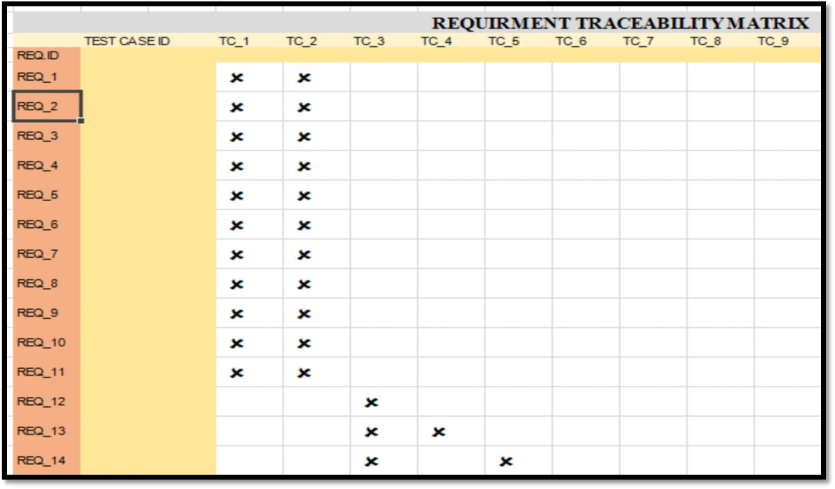

**Figure 14****: Traceability Matrix**

## Test Plan

**Table 5. 1: Test Case for User Signup**

|  |  |
| --- | --- |
| **Test ID** | **TC_1** |
| **Test name** | User Signup |
| **Date of test** | 11/11/2021 |
| **Name of application** | Mewa Community Forum |
| **Description** | Register new user with the valid data. |
| **Input** | Username: abc  Email: [abc@example.com](mailto:abc@example.com)  Password: ****** |
| **Expected output** | User registered and redirected to main page of the application |
| **Actual output** | User registered and redirected to main page of the application |
| **Test Role (Actor)** | Team Member |
| **Test verified by** | Team Member/Supervisor |

**Table 5. 2: Test case for User Fail Signup**

|  |  |
| --- | --- |
| **Test ID** | **TC_2** |
| **Test name** | User Fail Signup |
| **Date of test** | 11/11/2021 |
| **Name of application** | Mewa Community Forum |
| **Description** | Register new user with the valid data. |
| **Input** | Username: abc  Email: [abc@example.com](mailto:abc@example.com)  Password: ****** |
| **Expected output** | User registration failed and stay on same page |
| **Actual output** | User registration failed and stay on same page |
| **Test Role (Actor)** | Team Member |
| **Test verified by** | Team Member/Supervisor |

**Table 5. 3: Test case for User Login**

|  |  |
| --- | --- |
| **Test ID** | **TC_3** |
| **Test name** | User Login |
| **Date of test** | 11/11/2021 |
| **Name of application** | Mewa Community Forum |
| **Description** | User login with valid input data. |
| **Input** | Username: abc Password: ****** |
| **Expected output** | User logged in and redirected to main page |
| **Actual output** | User logged in and redirected to main page |
| **Test Role (Actor)** | Team Member |
| **Test verified by** | Team Member/Supervisor |

**Table 5. 4: Test case for Wrong Username**

|  |  |
| --- | --- |
| **Test ID** | **TC_4** |
| **Test name** | Wrong Username |
| **Date of test** | 11/11/2021 |
| **Name of application** | Mewa Community Forum |
| **Description** | User enter wrong username while logging in |
| **Input** | Username: abc |
| **Expected output** | Display flash message “Username does not exists” and stays on same page. |
| **Actual output** | Displayed flash message “Username does not exists” and stays on same page. |
| **Test Role (Actor)** | Team Member |
| **Test verified by** | Team Member/Supervisor |

**Table 5. 5: Test case for Wrong Password**

|  |  |
| --- | --- |
| **Test ID** | **TC_5** |
| **Test name** | Wrong Password |
| **Date of test** | 10/11/2021 |
| **Name of application** | Mewa Community Forum |
| **Description** | User enter invalid password while logging in |
| **Input** | Password: ****** |
| **Expected output** | Display flash message “Wrong Password” and stays on same page. |
| **Actual output** | Displayed flash message “Wrong Passord” and stays on same page. |
| **Test Role (Actor)** | Team Member |
| **Test verified by** | Team Member/Supervisor |

**Table 5. 6: Add User**

|  |  |
| --- | --- |
| **Test ID** | **TC_6** |
| **Test name** | Add User |
| **Date of test** | 11/11/2021 |
| **Name of application** | Mewa Community Forum |
| **Description** | Admin shall be able to add the information of new user. |
| **Input** | Click on button. |
| **Expected output** | Page will be refreshed and information is display. |
| **Actual output** | Admin will be add a new user. |
| **Test Role (Actor)** | Team Member |
| **Test verified by** | Team Member/Supervisor |

**Table 5. 7: Post a Question**

|  |  |
| --- | --- |
| **Test ID** | **TC_7** |
| **Test name** | Post a Question |
| **Date of test** | 12/11/2021 |
| **Name of application** | Mewa Community Forum |
| **Description** | Post a question. |
| **Input** | Click on button. |
| **Expected output** | Page will be refreshed and information is display. |
| **Actual output** | Page will be refreshed and information is display.. |
| **Test Role (Actor)** | Team Member |
| **Test verified by** | Team Member/Supervisor |

# USER MANUAL

This chapter will define that how the system works, dos and don’ts of the system. Which actions can be performed and which can’t?

## Introduction

In this chapter, we described how to use this system. How to install or setup in operating Environment. Instructions for usage of system, how to give inputs and get desired output from the system. This section will include the solution manual which will specifies the directions for the certain actions for user.

## Hardware/Software Requirements for the System

* **Hardware:**

**(Minimum requirements)**

1. CPU 1 Core.
2. RAM 1 GB.
3. SSD 20 GB.
4. Bandwidth 1 MB.
5. Dedicated IP.

**(Recommended requirements)**

1. CPU 4 Core
2. RAM 4 GB
3. SSD 80 GB
4. Bandwidth 2 MB
5. Dedicated IP
6. Full root access

* **Software:**

1. Visual Studio.
2. Laravel.
3. MSQL.

## Installation guide for Application

* + 1. **Installation guide for Laravel (Composer)**

Laravel needs composer to manage different extensions.

URL: <https://getcomposer.org/download/>

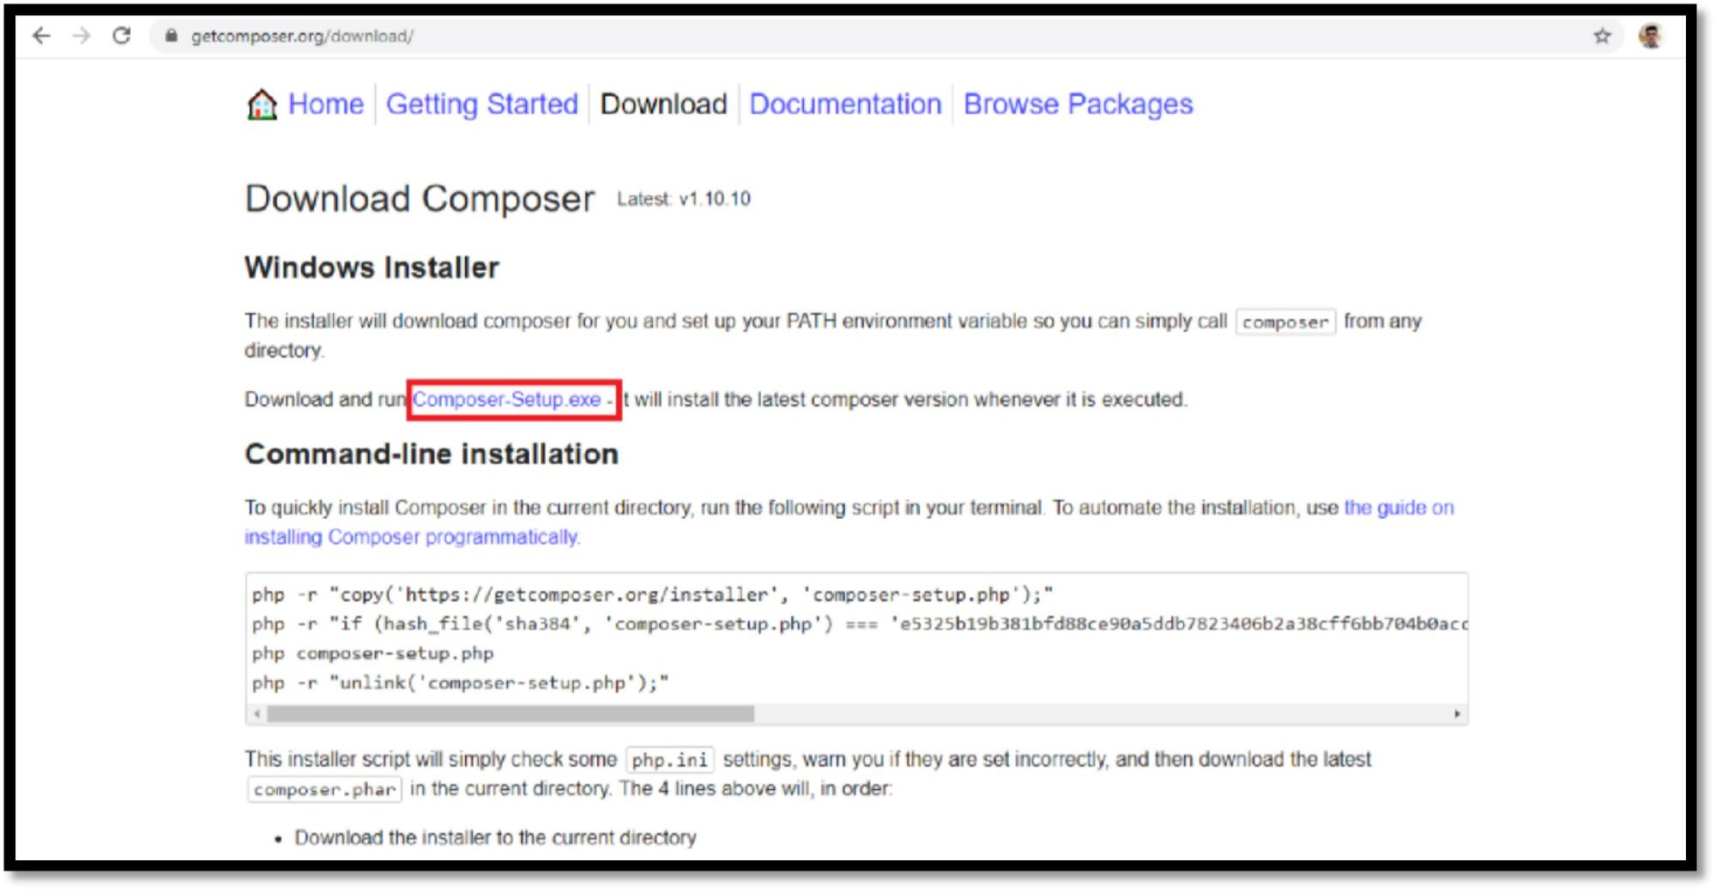

**Figure 1****5: Laravel Composer**

* + 1. **Run Composer after Download**

Run composer.exe after download. During installation, if you are prompted for php.exe path, its path in your system is **xampp/php** by default.

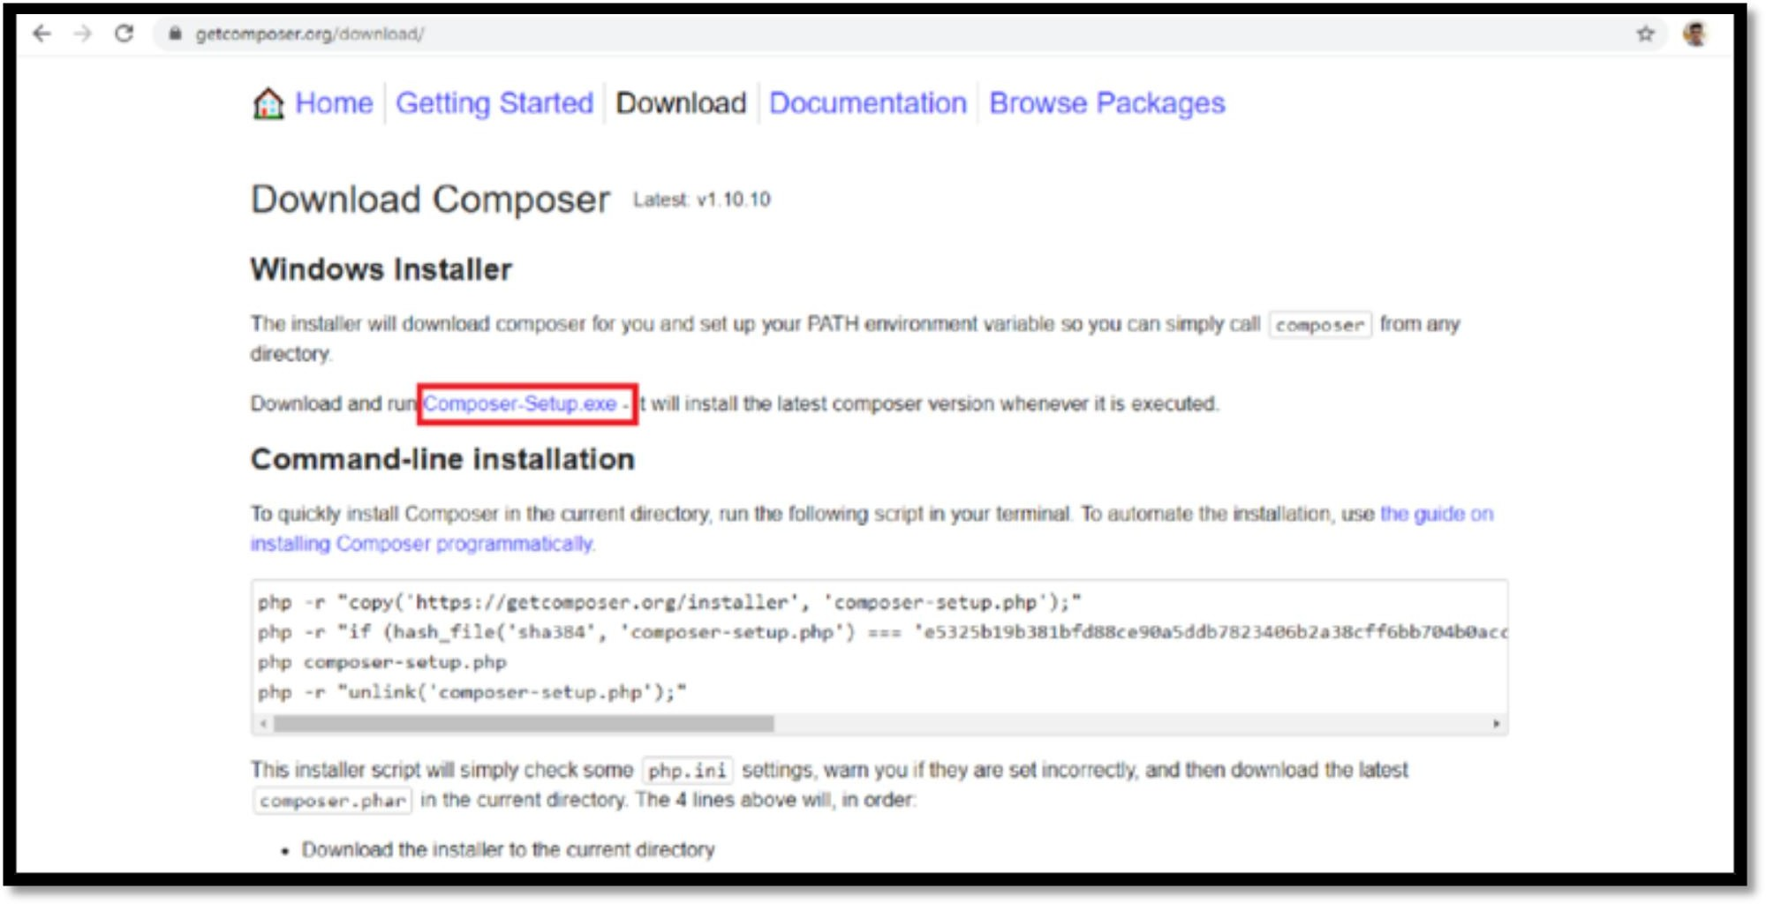

**Figure 16****: Download Composer**

Setup is ready to be installed.

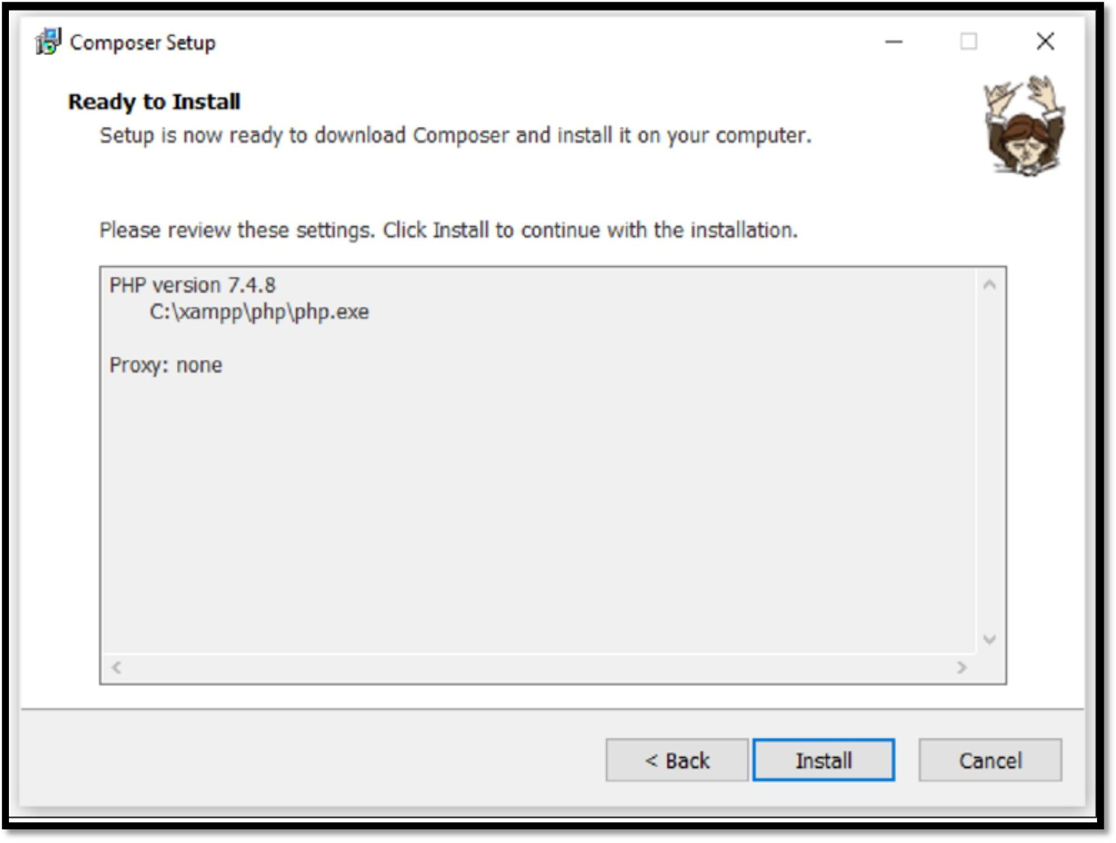

**Figure 17****: Install Composer**

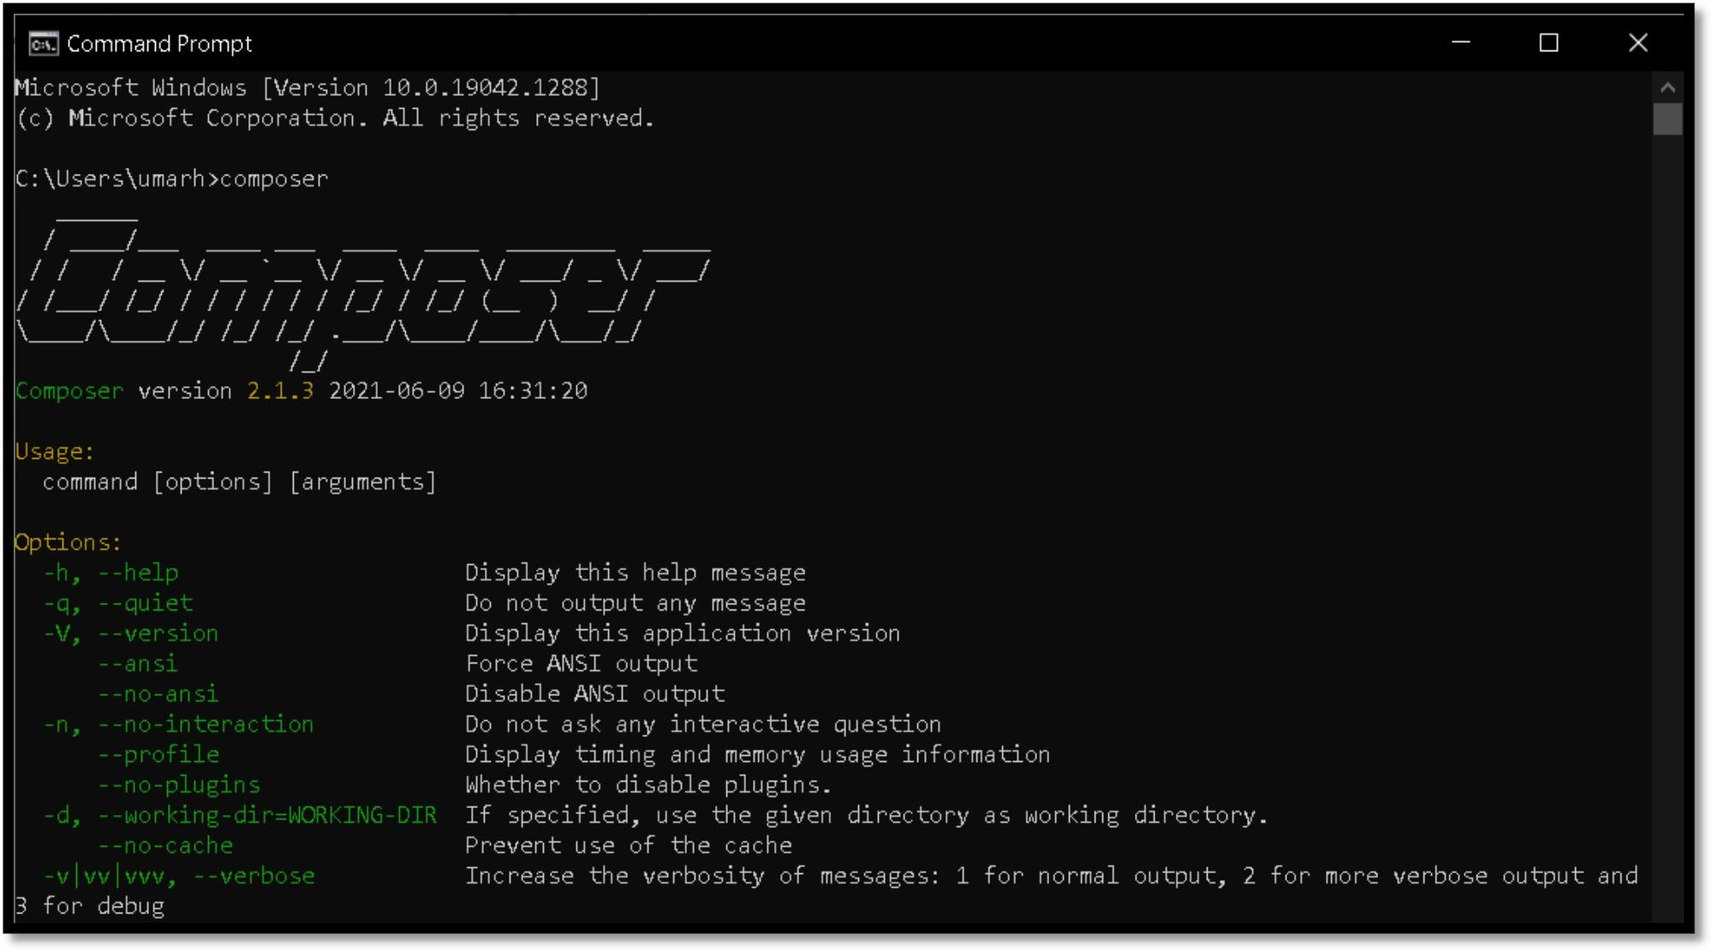

* + 1. **Install Laravel locally**

**Figure 18****: CMD Composer**

In global installation, Laravel is only installed once and then it is used for each new Project. In local installation, Laravel is installed for each new Project. Use the following URL to understand local and global installation of Laravel

URL: <https://laravel.com/docs/7.x/installation>

* + - * Type following commands in the Command Prompt to create a folder “Lawyer Hiring” and install Laravel in this folder. The name of our Laravel Project is “MEWA COMMUNITY FORUM”.
      * cd E:\xampp\htdocs
      * composer create-project laravel/laravel MEWA COMMUNITY FORUM.

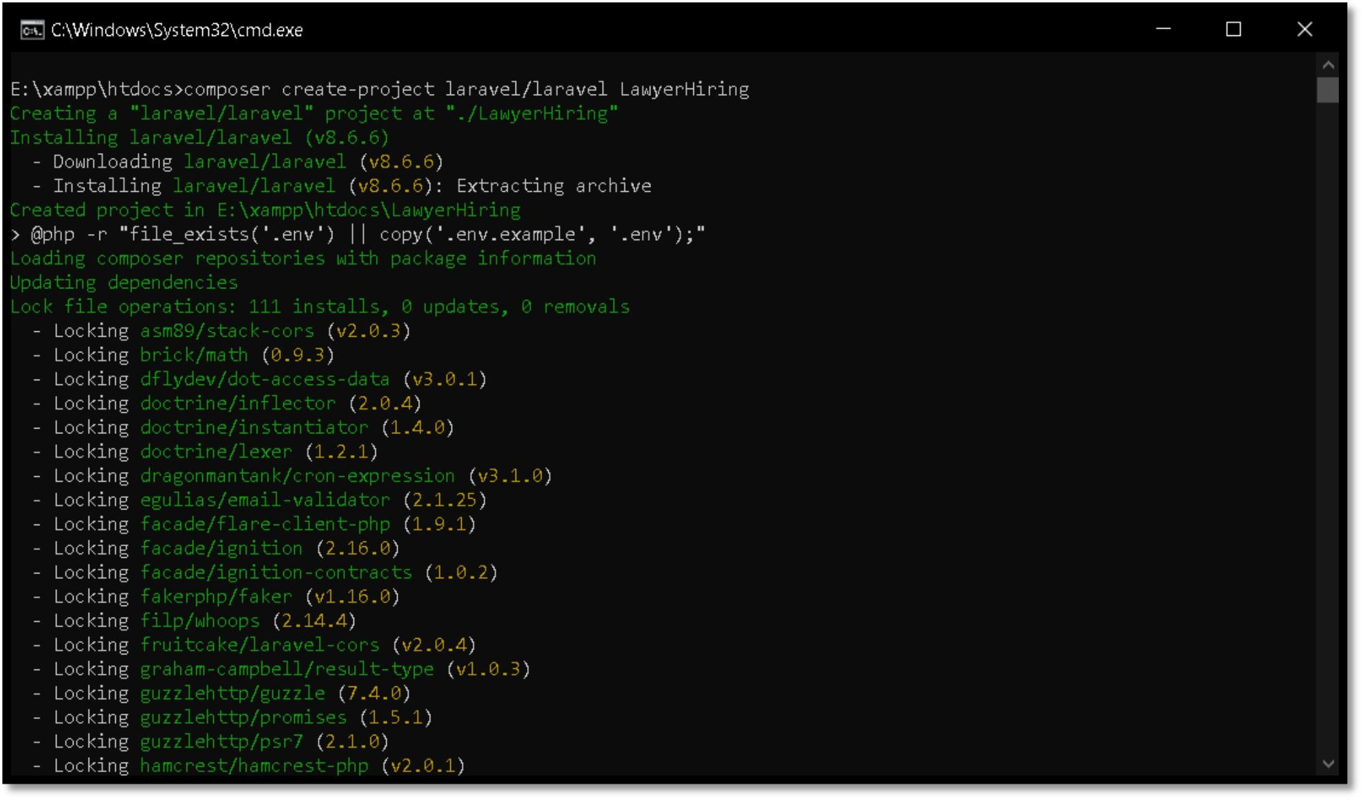

**Figure 19****: Configure Composer**

* After few seconds laravel will be installed successfully.

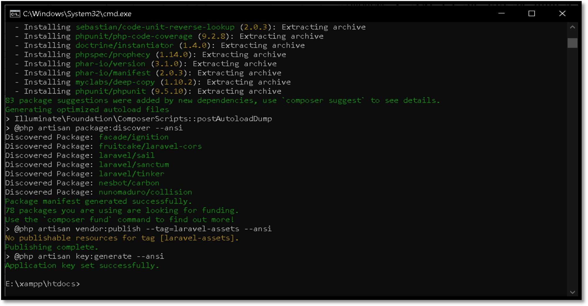

**Figure 20****: Composer Key Set Successfully**

* Laravel has been successfully installed in the project folder Mewa Community Forum.
* After installation, type the following commands in the Command Prompt to go the LawyerHiring folder and start there the **PHP** development server, for development and testing.

1. **cd Mewa Community Forum**
2. **php artisan serve**

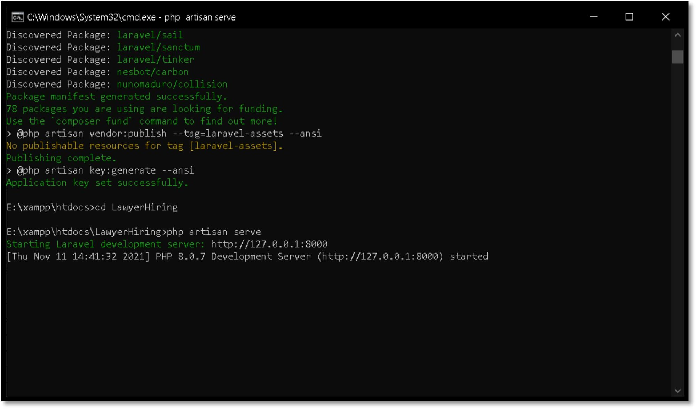

**Figure 21****: php artisan serve**

* Now, open the browser and type one of the following in the addresses bar to start the Laravel application
  + **http://127.0.0.1:8000**
  + http://localhost:8000

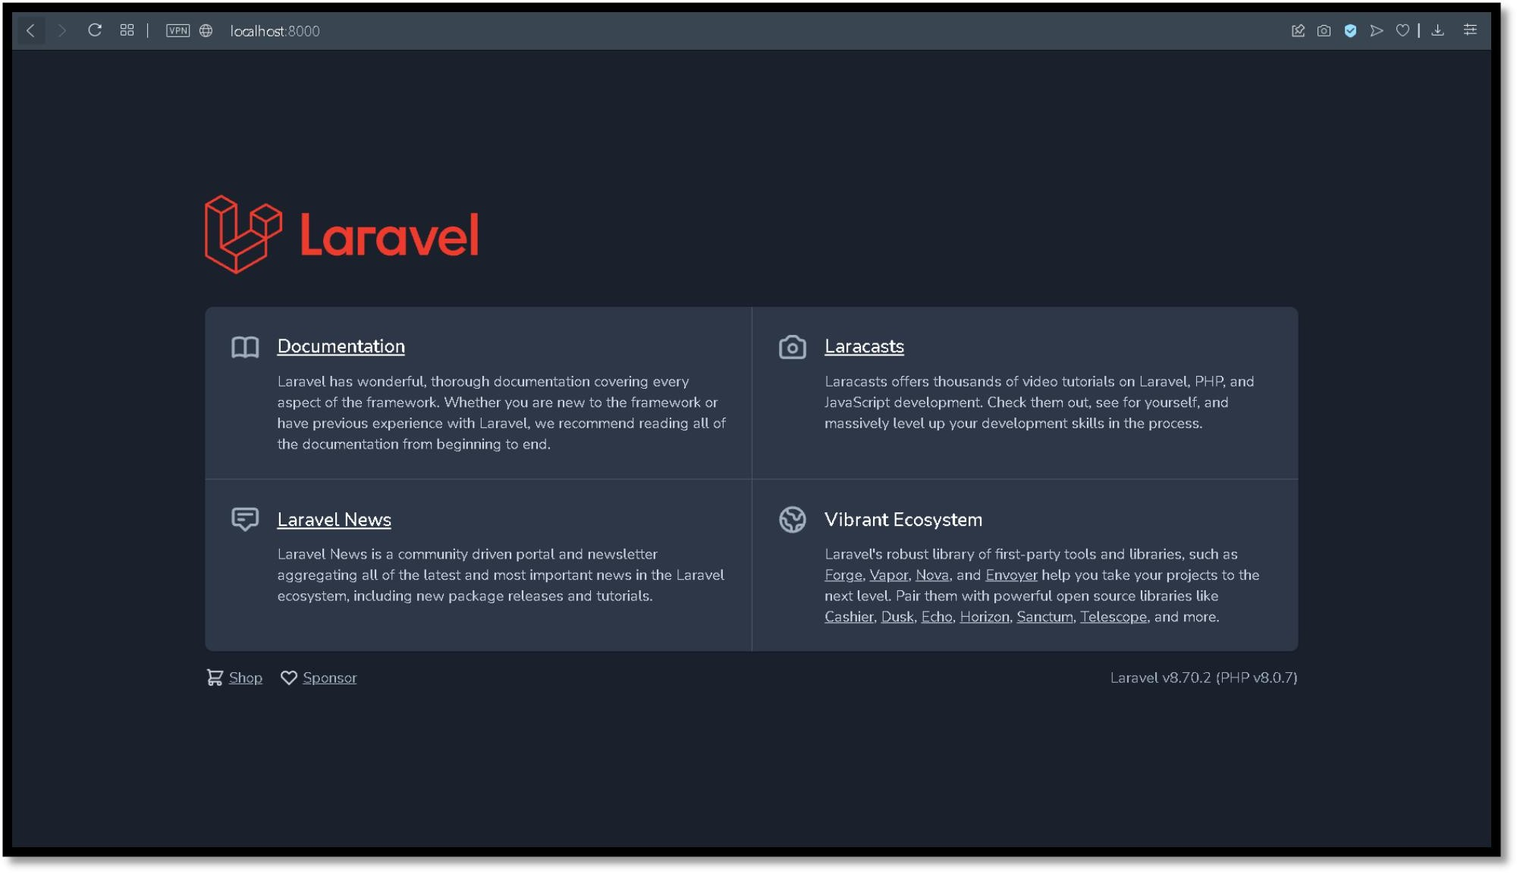

* + 1. **Download Visual Studio Code**

**Figure 22****: local host**

**URL:** <https://code.visualstudio.com/download>

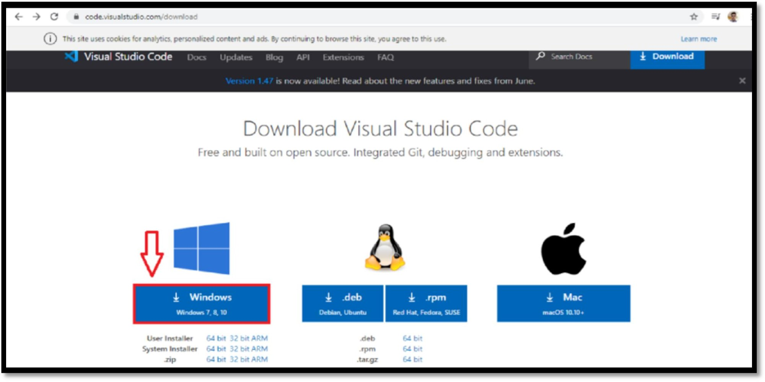

**Figure 23****: Visual Studio Code**

* Check **“I accept the agreement”.**

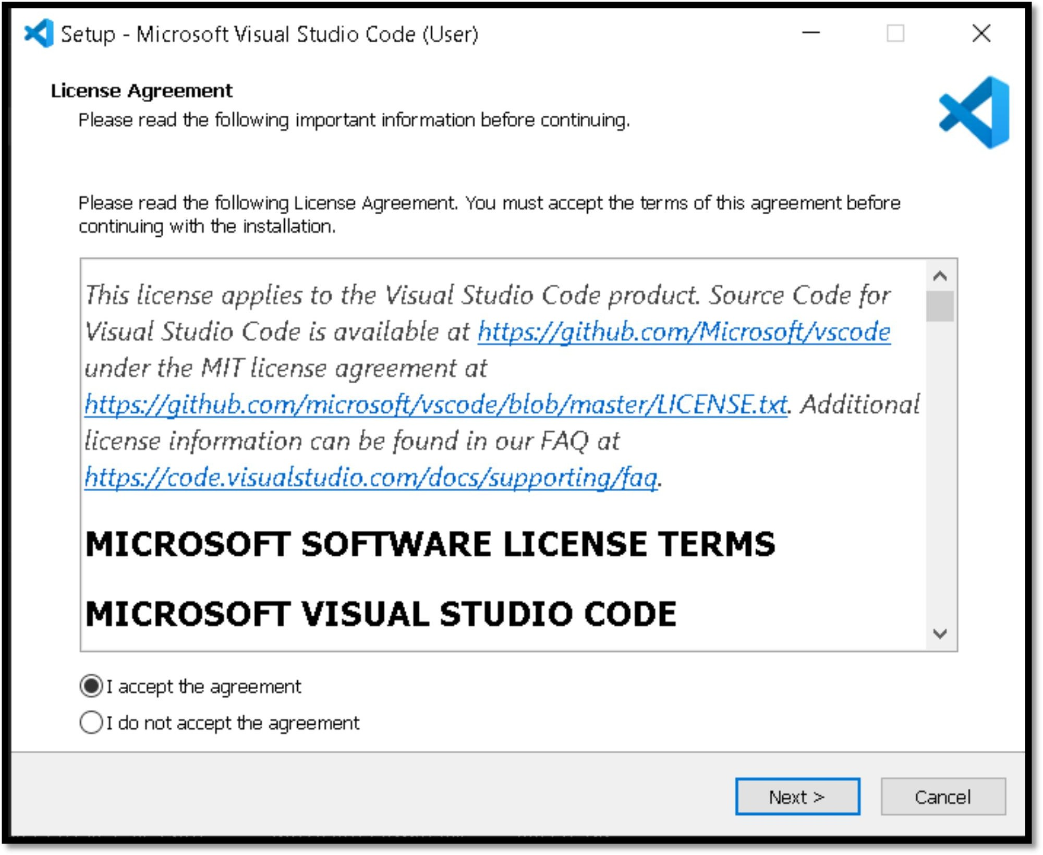

**Figure 2****4: Setup Agreement**

* Set the installation path.

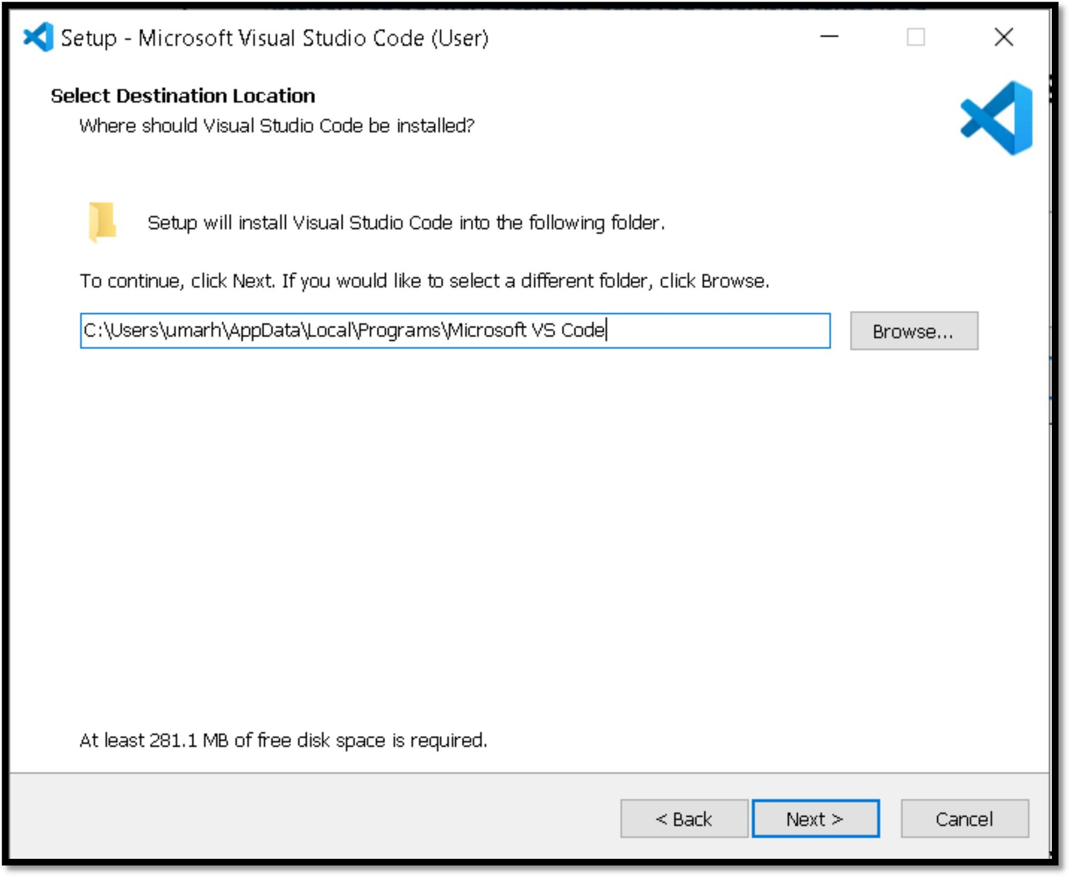

**Figure 2****5: Installation Path**

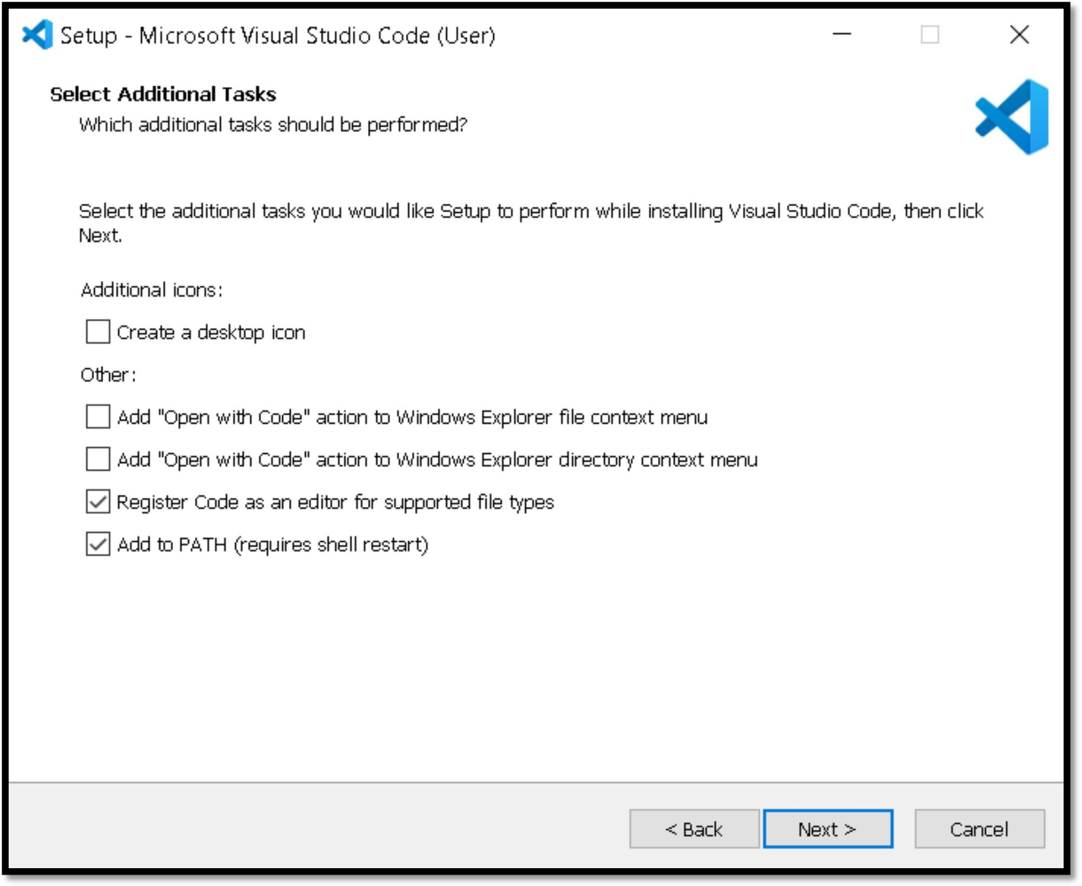

**Figure 2****6: Additional Task**

* Click Install to install the **VS Code**.

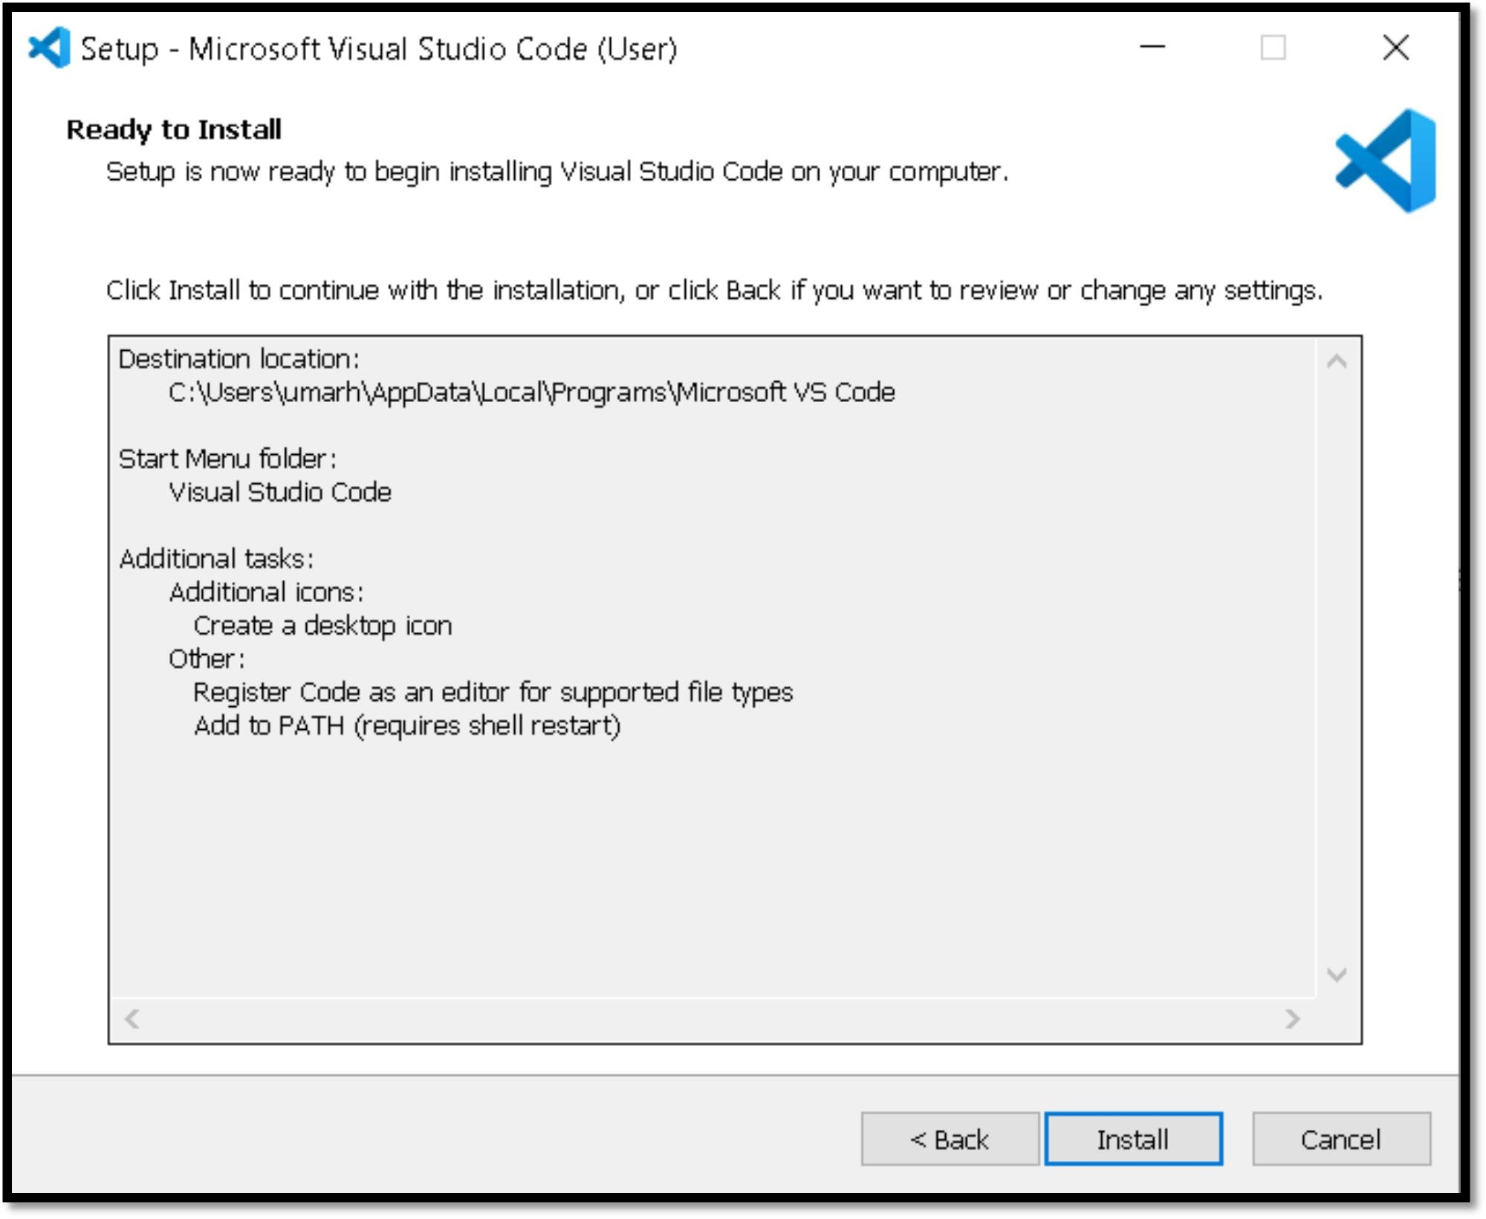

**Figure 2****7: Install VS Code**

* Launch **VS Code**.

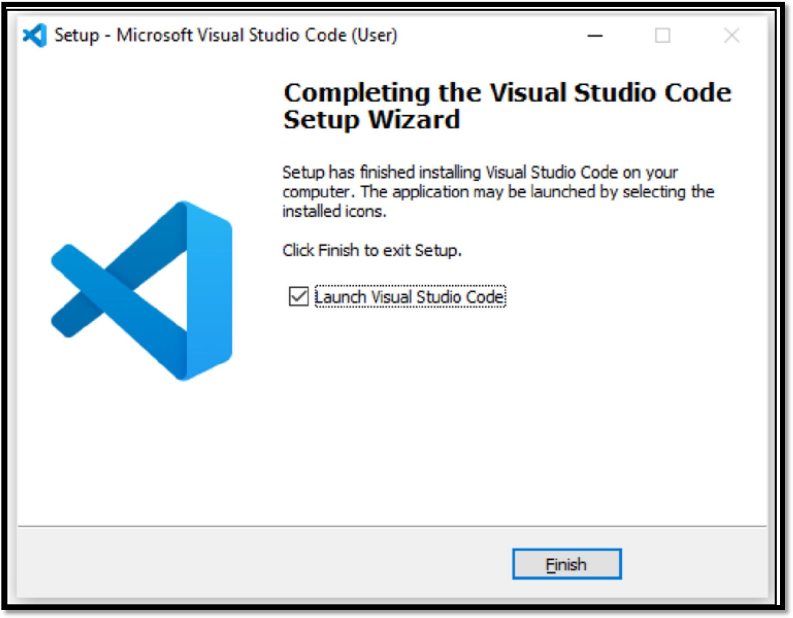

**Figure 28****: Finish VS Code**

* Using Open Project option of **VS Code** editor.

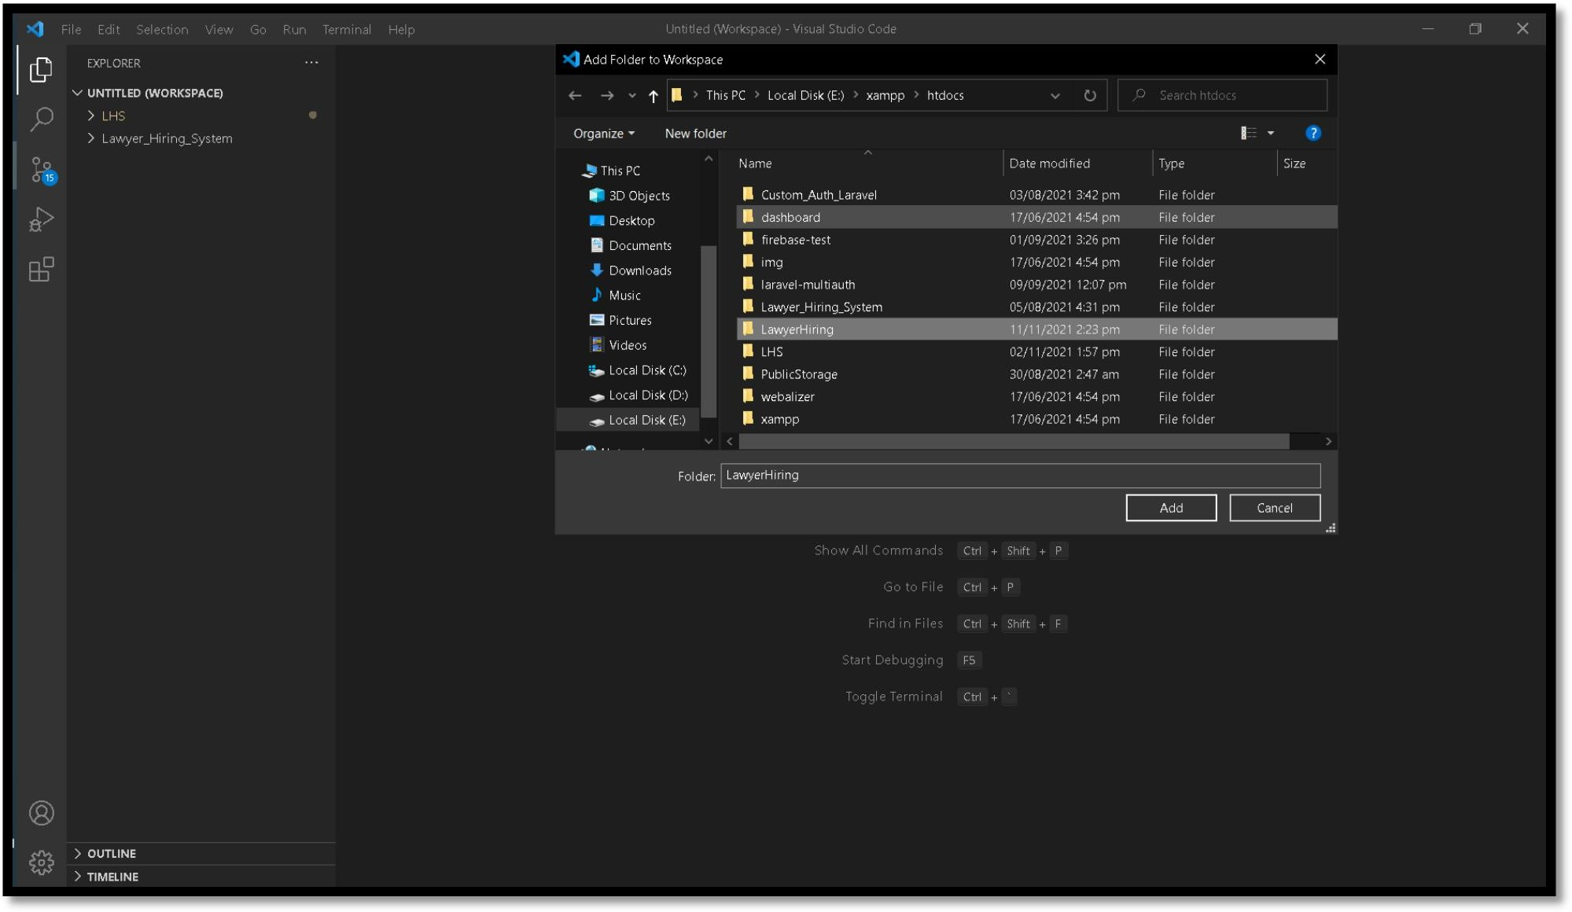

**Figure 2****9: VS Code Editor**

**For Website:**

* + Website can be opened on mobile, PC or laptop on any browser but to access website user must have the internet access.

## Operating Manual

### 6.4.1 Website Operating Manual

To visit website, you should have laptop, PC or smart phone with Google Chrome, Mozilla Firefox or Microsoft Edge installed in your device.

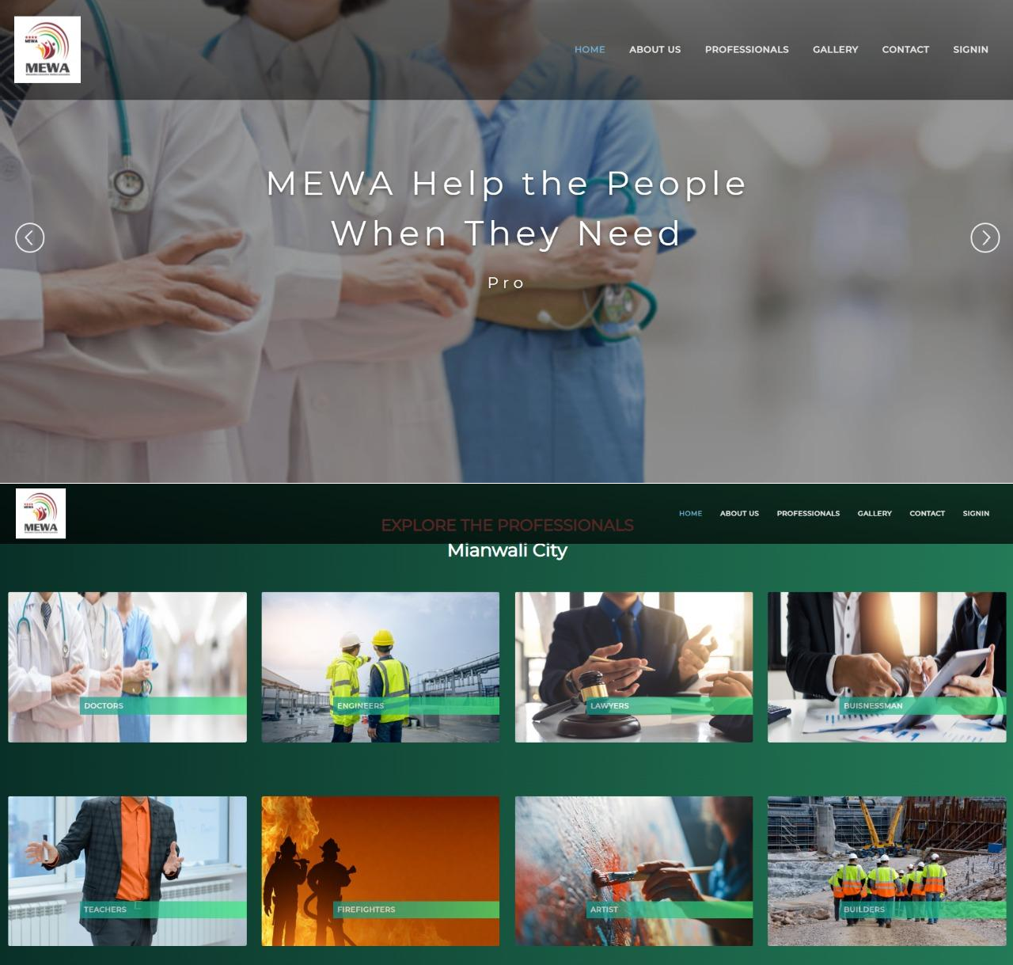

**Figure 3****0: Home Page**

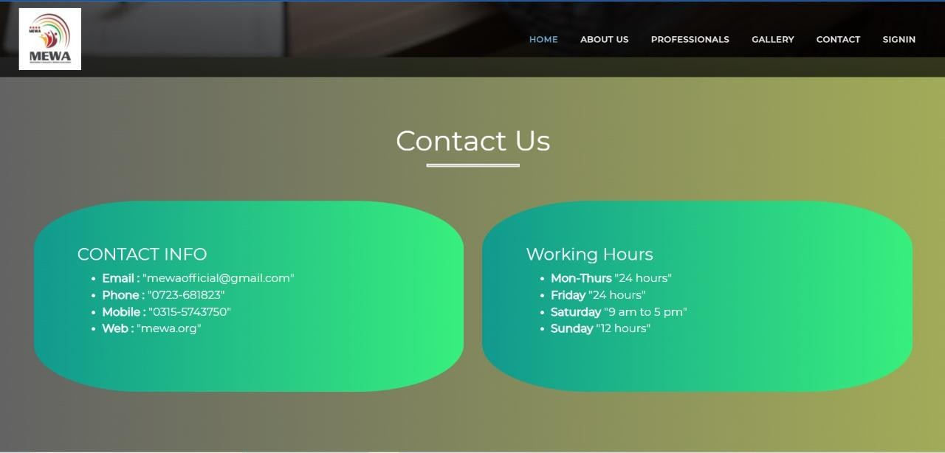

**Figure 3****1: Contacts**

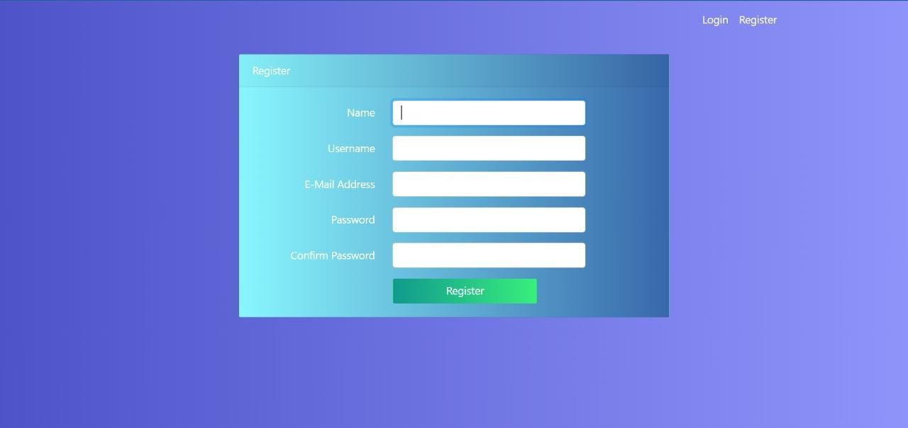

**Figure 3****2: Registration**

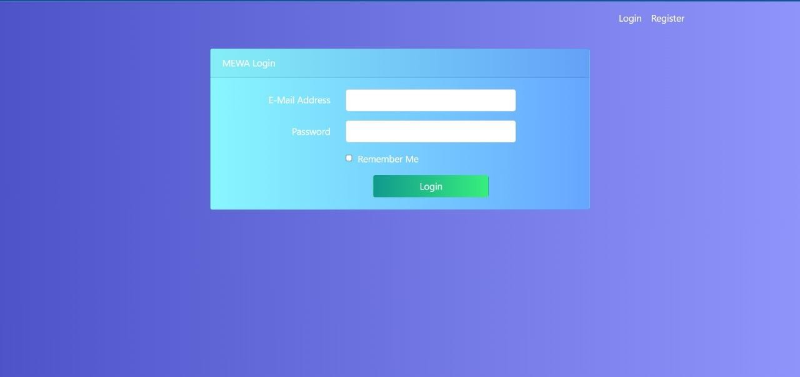

**Figure 3****3: Login**

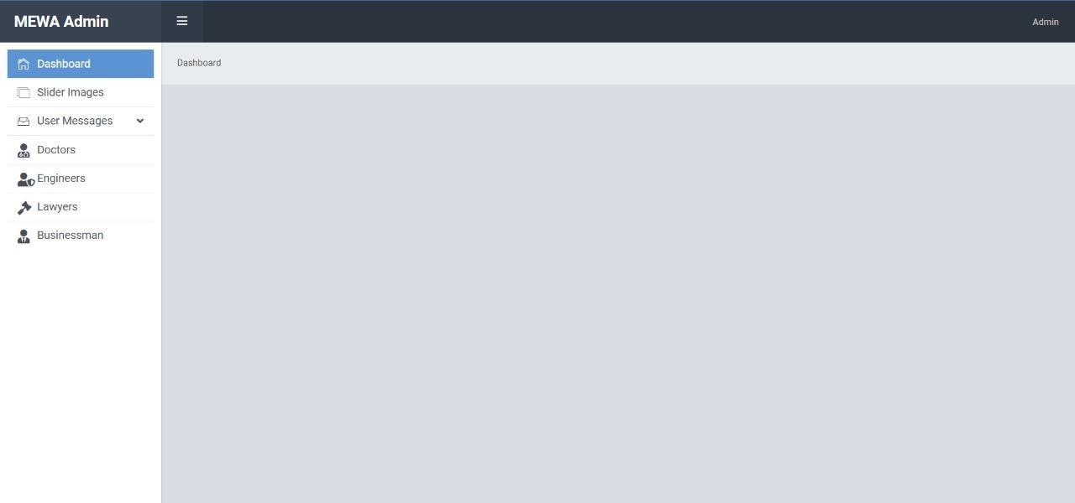

**Figure 3****4: MEWA Admin**

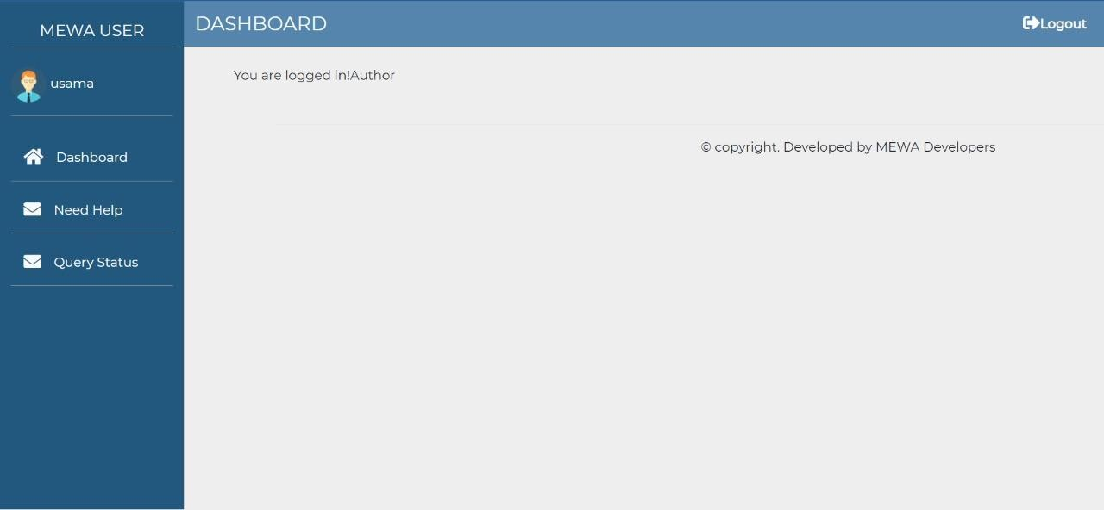

**Figure 3****5: MEWA User**

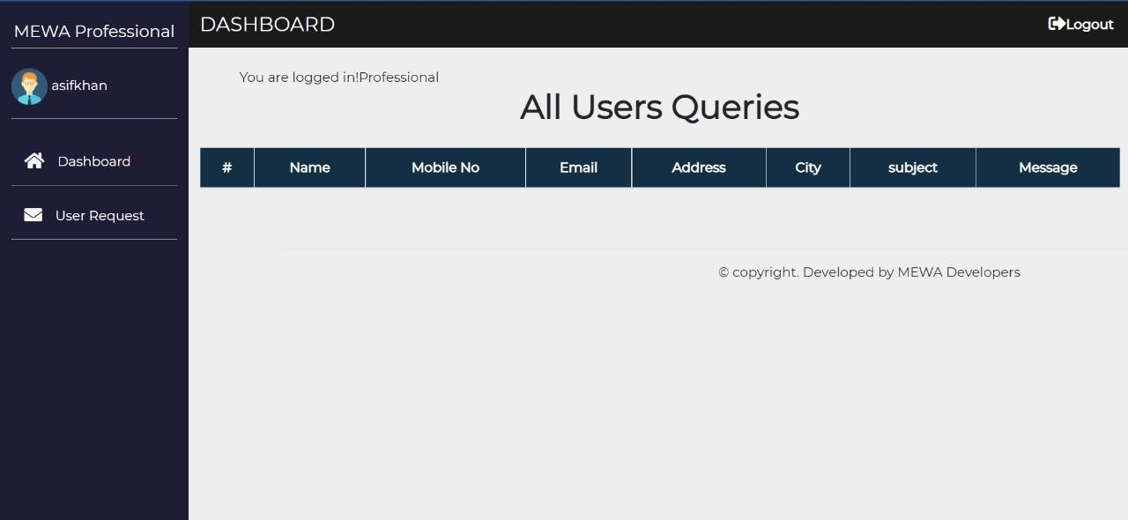

**Figure 36****: MEWA Professionals**